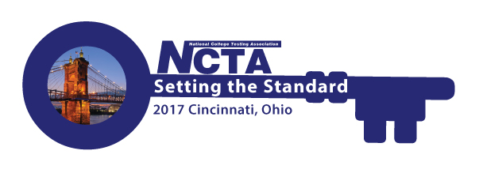
NCTA 2017 Annual Conference Committee Meeting
Monday, June 19, 2017
2:00 PM Eastern Time
GoToMeeting
https://global.gotomeeting.com/join/554423357

You can also dial in using your phone.
United States: +1 (646) 749-3112

Access Code: 554-423-357

Agenda

- Roll Call - Jody Atkins
- Committee Updates – Cindy James (chair)
    - Marketing – Cindy James
    - Program – Jim Wollack/Bob Lang
    - Virtual Conference – David Espinoza
    - Sponsorships/Exhibits – Rosemary Freer/Jody Atkins
    - Resource Fair – Jamila Maxie
    - Host Committee – Paula Doughman
    - Conference App – Amystique Church
- Conference Planner Updates – Jody Atkins
    - Registration Report
    - Housing Report
  - Other/New Business
- Adjourn – Next meeting is ???? – Jody can’t make July 17.

